**PJ 2 Report My Name: _Yaowei Lei__**

**A. The following is my Python source program:**

**// Please copy your source program into here from your Visual Studio IDE.**

**// Your code here must be in color. You must not show screen prints here.**

**# ============================================================**

**# Author: Yaowei Lei**

**# Date: 10/18/2021**

**# Purpose: CS119-PJ2: Compute and print a professional investment report.**

**# MAIN PROGRAM :**

**n = 1 # line number for each separator line for readability of the output**

**print ("Welcome to the Investment Report Tool of Yaowei Lei!") # must use your name!**

**print(n,"======================================================."); n+=1;**

**# Accept the inputs**

**startBalance = float(input("Enter the investment amount: "))**

**years = int(input("Enter the number of years: "))**

**rate = float(input("Enter the rate as a %: "))**

**print(n,"======================================================."); n+=1;**

**# Convert the rate to a decimal number**

**rate = rate / 100**

**# Initialize the accumulator for the interest**

**totalInterest = 0.0**

**# Display the header for the table**

**print("%4s%18s%10s%16s" % ("Year", "Starting balance", "Interest", "Ending balance"))**

**# Compute and display the results for each year**

**for year in range(1, years + 1):**

**interest = startBalance * rate**

**endBalance = startBalance + interest**

**print("%4d%18.2f%10.2f%16.2f" % (year, startBalance, interest, endBalance))**

**startBalance = endBalance**

**totalInterest += interest**

**print(n,"======================================================."); n+=1;**

**# Display the totals for the period**

**print("Ending balance: $%0.2f" % endBalance)**

**print("Total interest earned: $%0.2f" % totalInterest)**

**print(n,"======================================================."); n+=1;**

**print("Thank you for using the Investment Report Tool of Yaowei Lei! ") # must use your name!**

**print(n,"======================================================."); n+=1;**

**x = input("Press Ctrl+Alt+PrtScn to get a snapshot of this console, then Enter to exit: ")**

**# End of MAIN PROGRAM**

**B. The following is the console output of my 3 test runs:**

**// One way to copy the console output is to press Ctrl+Alt+PrtScn.**

**// Another way to copy is to use the snipping tool. To paste the image is to press Ctrl+v.**

**// The console display must not be too wide, otherwise it will be too hard to read once pasted.**

**// Please make sure your console is long enough to show all your output lines to be captured.**

**// Please copy your console output and paste into here:**

**Test Case 1:**

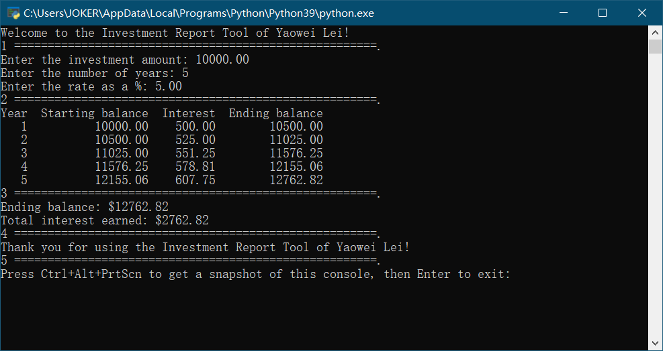

**Test Case 2:**

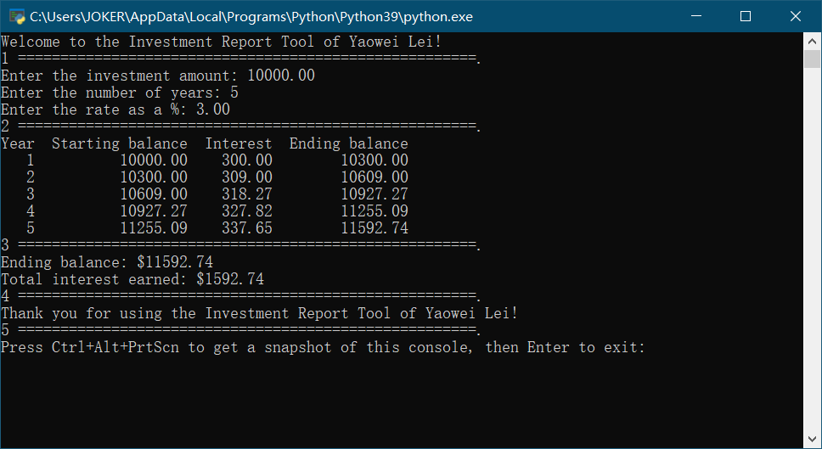

**Test Case 3:**

